IP Routing Basics



Huawei Technologies Co., Ltd.

|  |
| --- |
| **Copyright © Huawei Technologies Co., Ltd. 2020. All rights reserved.**  No part of this document may be reproduced or transmitted in any form or by any means without prior written consent of Huawei Technologies Co., Ltd.  **Trademarks and Permissions**  HW_POS_RBG_Vertical-150ppi.png and other Huawei trademarks are trademarks of Huawei Technologies Co., Ltd.  All other trademarks and trade names mentioned in this document are the property of their respective holders.  **Notice**  The purchased products, services and features are stipulated by the contract made between Huawei and the customer. All or part of the products, services and features described in this document may not be within the purchase scope or the usage scope. Unless otherwise specified in the contract, all statements, information, and recommendations in this document are provided "AS IS" without warranties, guarantees or representations of any kind, either express or implied.  The information in this document is subject to change without notice. Every effort has been made in the preparation of this document to ensure accuracy of the contents, but all statements, information, and recommendations in this document do not constitute a warranty of any kind, express or implied. |

|  |  |
| --- | --- |
| Huawei Technologies Co., Ltd. | |
| Address: | Huawei Industrial Base  Bantian, Longgang  Shenzhen 518129  People's Republic of China |
| Website: | <https://e.huawei.com/> |

**Huawei Certification System**

Huawei Certification follows the "platform + ecosystem" development strategy, which is a new collaborative architecture of ICT infrastructure based on "Cloud-Pipe-Terminal". Huawei has set up a complete certification system consisting of three categories: ICT infrastructure certification, platform and service certification, and ICT vertical certification. It is the only certification system that covers all ICT technical fields in the industry. Huawei offers three levels of certification: Huawei Certified ICT Associate (HCIA), Huawei Certified ICT Professional (HCIP), and Huawei Certified ICT Expert (HCIE). Huawei Certification covers all ICT fields and adapts to the industry trend of ICT convergence. With its leading talent development system and certification standards, it is committed to fostering new ICT talent in the digital era, and building a sound ICT talent ecosystem.

Huawei Certified ICT Associate-Datacom (HCIA-Datacom) is designed for Huawei's frontline engineers and anyone who want to understand Huawei's datacom products and technologies. The HCIA-Datacom certification covers routing and switching principles, basic WLAN principles, network security basics, network management and O&M basics, SDN and programmability and automation basics.

The Huawei certification system introduces the industry, fosters innovation, and imparts cutting-edge datacom knowledge.

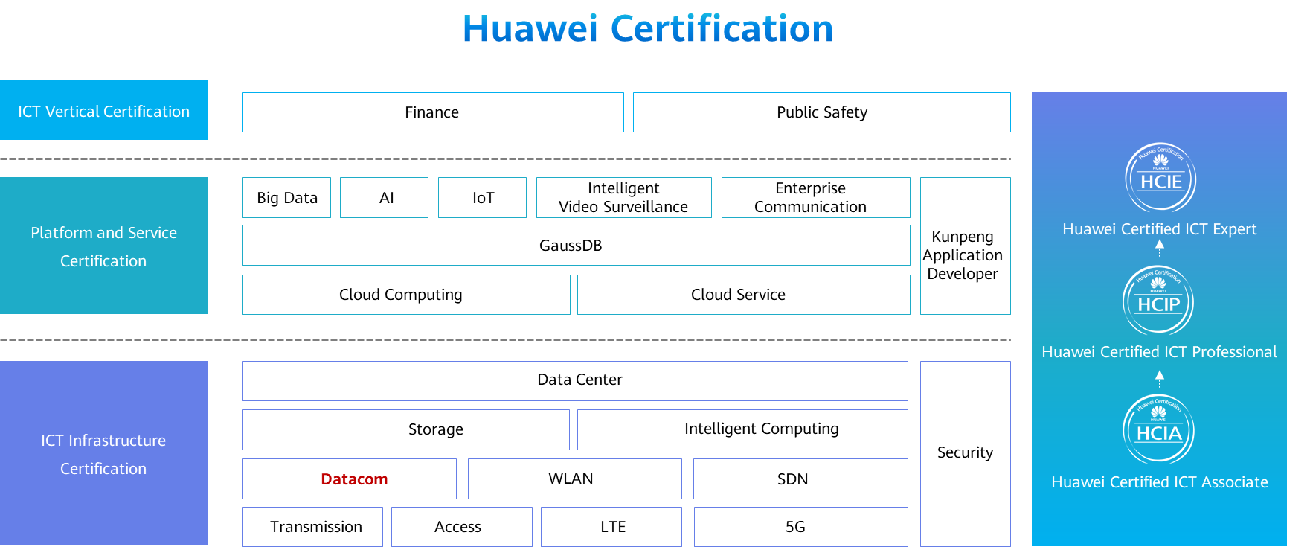

Contents

[1 IP Routing Basics 1](#_Toc60148963)

[1.1 Foreword 1](#_Toc60148964)

[1.2 Objectives 1](#_Toc60148965)

[1.3 Overview of IP Routing 1](#_Toc60148966)

[1.3.1 Background: Inter-Subnet Communication 1](#_Toc60148967)

[1.3.2 Routes 2](#_Toc60148968)

[1.3.3 Routing Information 2](#_Toc60148969)

[1.3.4 IP Routing Table 3](#_Toc60148970)

[1.3.5 How to Obtain Routing Information 3](#_Toc60148971)

[1.3.6 Direct Routes 5](#_Toc60148972)

[1.3.7 Examining the IP Routing Table 6](#_Toc60148973)

[1.3.8 Fields in the IP Routing Table 6](#_Toc60148974)

[1.3.9 Route Preference 7](#_Toc60148975)

[1.3.10 Metric 8](#_Toc60148976)

[1.3.11 Longest Matching 9](#_Toc60148977)

[1.3.12 Route-based Forwarding Process 11](#_Toc60148978)

[1.3.13 Summary of the IP Routing Table 11](#_Toc60148979)

[1.4 Static Routing 12](#_Toc60148980)

[1.4.1 Application Scenarios of Static Routes 12](#_Toc60148981)

[1.4.2 Static Route Configuration 12](#_Toc60148982)

[1.4.3 Default Routes 13](#_Toc60148983)

[1.4.4 Application Scenarios of Default Routes 14](#_Toc60148984)

[1.5 Dynamic Routing 14](#_Toc60148985)

[1.5.1 Overview of Dynamic Routing 14](#_Toc60148986)

[1.5.2 Classification of Dynamic Routing Protocols 15](#_Toc60148987)

[1.6 Advanced Routing Features 16](#_Toc60148988)

[1.6.1 Route Recursion 16](#_Toc60148989)

[1.6.2 Equal-Cost Route 16](#_Toc60148990)

[1.6.3 Floating Route 17](#_Toc60148991)

[1.6.4 CIDR 18](#_Toc60148992)

[1.6.5 Background of Route Summarization 18](#_Toc60148993)

[1.6.6 Overview of Route Summarization 19](#_Toc60148994)

[1.6.7 Summarization and Calculation 20](#_Toc60148995)

[1.6.8 Problems Caused by Route Summarization 20](#_Toc60148996)

[1.6.9 Accurate Route Summarization 21](#_Toc60148997)

[1.7 Quiz 22](#_Toc60148998)

[1.8 Summary 23](#_Toc60148999)

# IP Routing Basics

## Foreword

There are typically multiple IP subnets on a typical data communication network. Layer 3 devices are required to exchange data between these IP subnets. These devices have the routing capability and can forward data across subnets.

Routing is the basic element of data communication networks. It is the process of selecting paths on a network along which packets are sent from a source to a destination.

This course introduces the basic concepts of routing.

## Objectives

On completion of this course, you will be able to:

Understand the basic principles of routers.

Know how routers select optimal routes.

Understand the contents of routing tables.

Master advanced routing features.

## Overview of IP Routing

### Background: Inter-Subnet Communication

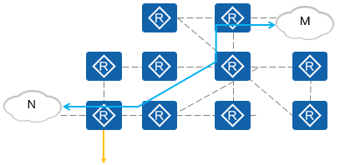

How to communicate with the network M?

A unique network node can be found based on a specific IP address. Each IP address belongs to a unique subnet. These subnets may be distributed around the world and constitute a global network.

To implement communication between different subnets, network devices need to forward IP packets from different subnets to their destination IP subnets.

### Routes

Routes are the path information used to guide packet forwarding.

A routing device is a network device that forwards packets to a destination subnet based on routes. The most common routing device is a router.

A routing device maintains an IP routing table that stores routing information.

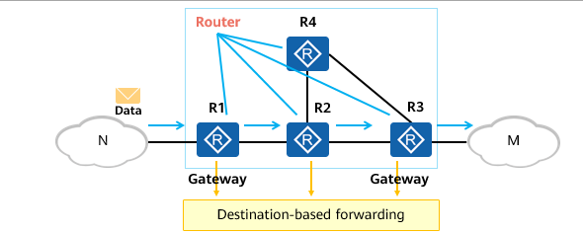

Route-based Packet Forwarding

A gateway and an intermediate node (a router) select a proper path according to the destination address of a received IP packet, and forward the packet to the next router. The last-hop router on the path performs Layer 2 addressing and forwards the packet to the destination host. This process is called route-based forwarding.

The intermediate node selects the best path from its IP routing table to forward packets.

A routing entry contains a specific outbound interface and next hop, which are used to forward IP packets to the corresponding next-hop device.

### Routing Information

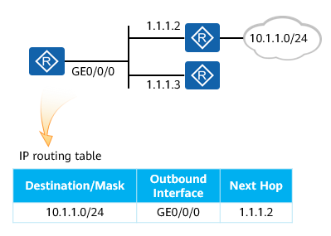

Routing Information

A route contains the following information:

* Destination: identifies a destination subnet.
* Mask: identifies a subnet together with a destination IP address.
* Outbound interface: indicates the interface through which a data packet is sent out of the local router.
* Next hop: indicates the next-hop address used by the router to forward the data packet to the destination subnet.

The information identifies the destination subnet and specifies the path for forwarding data packets.

Based on the information contained in a route, a router can forward IP packets to the destination along the required path.

The destination address and mask identify the destination address of an IP packet. After an IP packet matches a specific route, the router determines the forwarding path according to the outbound interface and next hop of the route.

The next-hop device for forwarding the IP packet cannot be determined based only on the outbound interface. Therefore, the next-hop device address must be specified.

### IP Routing Table

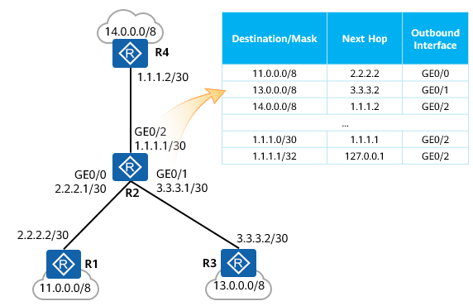

IP Routing Table

Routers discover routes using multiple methods.

A router selects the optimal route and installs it in its IP routing table.

The router forwards IP packets based on routes in the IP routing table.

Routers manage path information by managing their IP routing tables.

A router forwards packets based on its IP routing table.

An IP routing table contains many routing entries.

An IP routing table contains only optimal routes but not all routes.

A router manages routing information by managing the routing entries in its IP routing table.

### How to Obtain Routing Information

A router forwards packets based on its IP routing table. To implement route-based packet forwarding, the router needs to obtain routes. The following describes the common methods of obtaining routes.

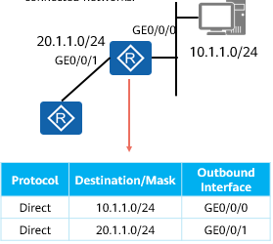

Direct Routes

Direct routes are the routes destined for the subnets to which directly connected interfaces belong. They are automatically generated by devices.

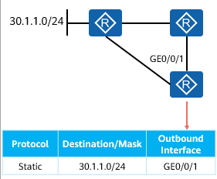

Static Routes

Static routes are manually configured by network administrators.

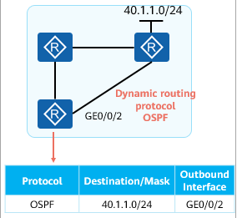

Dynamic Routes

Dynamic routes are learned by dynamic routing protocols, such as OSPF, IS-IS, and BGP.

### Direct Routes

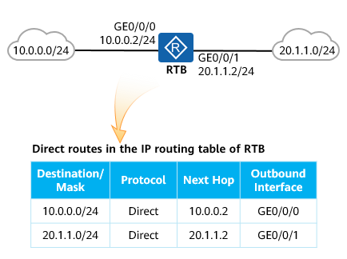

Direct Routes (1)

A direct route is automatically generated by a device and points to a local directly-connected network.

When a router is the last hop router, IP packets to be forwarded will match a direct route and the router will directly forward the IP packet to the destination host.

When a direct route is used for packet forwarding, the destination IP address of a packet to be forwarded and the IP address of the router‘s outbound interface are in the same subnet.

When a packet matches a direct route, a router checks its ARP entries and forwards the packet to the destination address based on the ARP entry for this destination address. In this case, the router is the last hop router.

The next-hop address of a direct route is not an interface address of another device. The destination subnet of the direct route is the subnet to which the local outbound interface belongs. The local outbound interface is the last hop interface and does not need to forward the packet to any other next hop. Therefore, the next-hop address of a direct route in the IP routing table is the address of the local outbound interface.

When a router forwards packets using a direct route, it does not deliver packets to the next hop. Instead, the router checks its ARP entries and forwards packets to the destination IP address based on the required ARP entry.

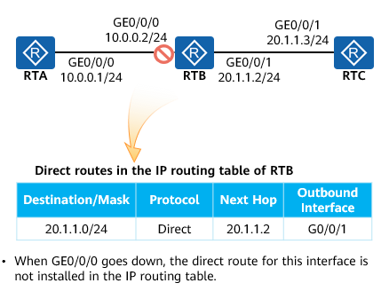

Direct Routes (2)

Not all the direct routes generated for interfaces are installed in the IP routing table. Only the direct routes of which the physical status and protocol status of interfaces are up are installed in the IP routing table.

### Examining the IP Routing Table

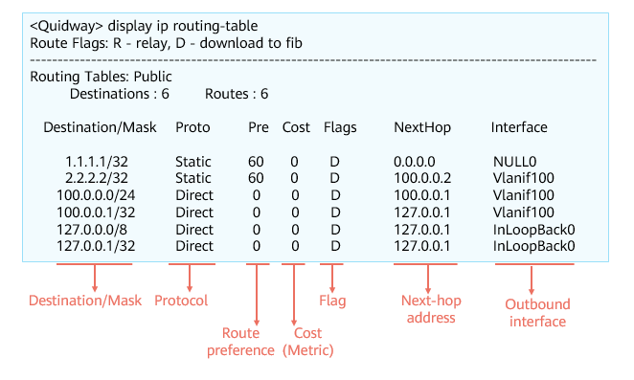

IP Routing Table

### Fields in the IP Routing Table

Destination/Mask: indicates the destination network address and mask of a specific route. The subnet address of a destination host or router is obtained through the AND operation on the destination address and mask. For example, if the destination address is 1.1.1.1 and the mask is 255.255.255.0, the IP address of the subnet to which the host or router belongs is 1.1.1.0.

Proto (Protocol): indicates the protocol type of the route, that is, the protocol through which a router learns the route.

Pre (Preference): indicates the routing protocol preference of the route. There may be multiple routes to the same destination, which have different next hops and outbound interfaces. These routes may be discovered by different routing protocols or be manually configured. A router selects the route with the highest preference (with the lowest preference value) as the optimal route.

Cost: indicates the cost of the route. When multiple routes to the same destination have the same preference, the route with the lowest cost is selected as the optimal route.

NextHop: indicates the local router’s next-hop address of the route to the destination network. This field specifies the next-hop device to which packets are forwarded.

Interface: indicates the outbound interface of the route. This field specifies the local interface through which the local router forwards packets.

Preference field is used to compare routes from different routing protocols, while the Cost field is used to compare routes from the same routing protocol. In the industry, the cost is also known as the metric.

### Route Preference

Basic Concepts

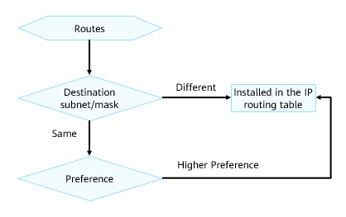

Comparing Route Preferences

* When a router obtains routes to the same destination subnet from different routing protocols (these routes have the same destination network address and mask), the router compares the preferences of these routes and prefers the route with the lowest preference value.
* A lower preference value indicates a higher preference.
* The route with the highest preference is installed in the IP routing table.

Comparison Process

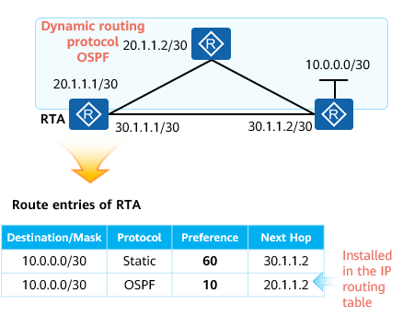

Comparing Route Preferences

* RTA discovers two routes to 10.0.0.0/30, one is an OSPF route and the other a static route. In this case, RTA compares the preferences of the two routes and selects the route with the lowest preference value.
* Each routing protocol has a unique preference.
* OSPF has a higher preference. Therefore, the OSPF route is installed in the IP routing table.
* RTA learns two routes to the same destination, one is a static route and the other an OSPF route. It then compares the preferences of the two routes, and prefers the OSPF route because this route has a higher preference. RTA installs the OSPF route in the IP routing table.

Common Default Values

The following table lists the default preference values of common route types:

Common Default Values

|  |  |  |
| --- | --- | --- |
| Protocol | Route Type | Default Preference |
| Direct | Direct route | 0 |
| Static | Static route | 60 |
| Dynamic routing protocol | OSPF internal route | 10 |
| OSPF external route | 150 |

The table lists the preferences of some common routing protocols. Actually, there are multiple types of dynamic routes. We will learn these routes in subsequent courses.

### Metric

Basic Concepts

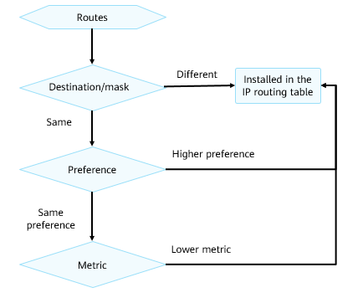

Comparing Metrics

* When a router discovers multiple routes to the same destination network through the same routing protocol, the router selects the optimal route based on the metrics of these routes if these routes have the same preference.
* The metric of a route indicates the cost of reaching the destination address of the route.
* Common metrics include the hop count, bandwidth, delay, cost, load, and reliability.
* The route with the lowest metric is installed in the IP routing table.
* The metric is also known as the cost.

Comparison Process

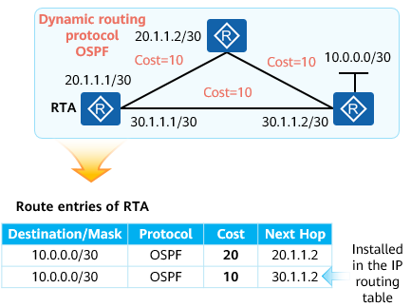

Metric comparison

* RTA learns two routes with the same destination address (10.0.0.0/30) and preference through OSPF. In this case, RTA needs to compare the metrics of the two routes.
* The two routes have different metrics. The OSPF route with the next hop being 30.1.1.2 has a lower metric (with the cost 10), so it is installed in the IP routing table.

### Longest Matching

When a router receives an IP packet, it compares the destination IP address of the packet with all routing entries in the local routing table bit by bit until the longest matching entry is found. This is the longest matching mechanism.

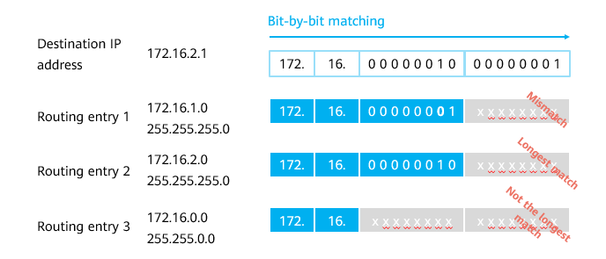

Longest Matching

Example of Longest Matching

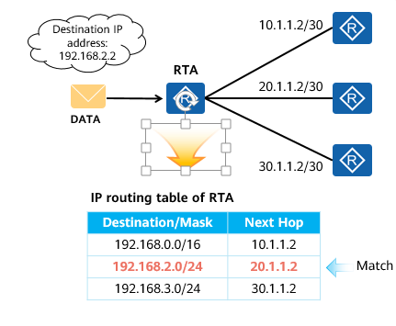

Example of Longest Matching (1)

* There are two routes to 192.168.2.2 in the IP routing table of RTA, one has the 16-bit mask and the other has the 24-bit mask. According to the longest matching rule, the route with the 24-bit mask is preferred to guide the forwarding of packets destined for 192.168.2.2.

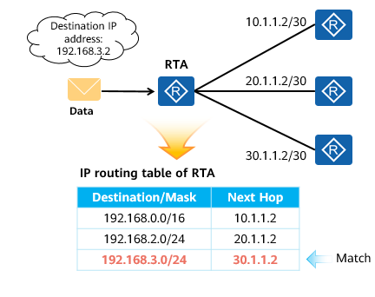

Example of Longest Matching (2)

* According to the longest matching rule, only the route to 192.168.3.0/24 in the IP routing table matches the destination IP address 192.168.3.2. Therefore, this route is used to forward packets destined for 192.168.3.2.

### Route-based Forwarding Process

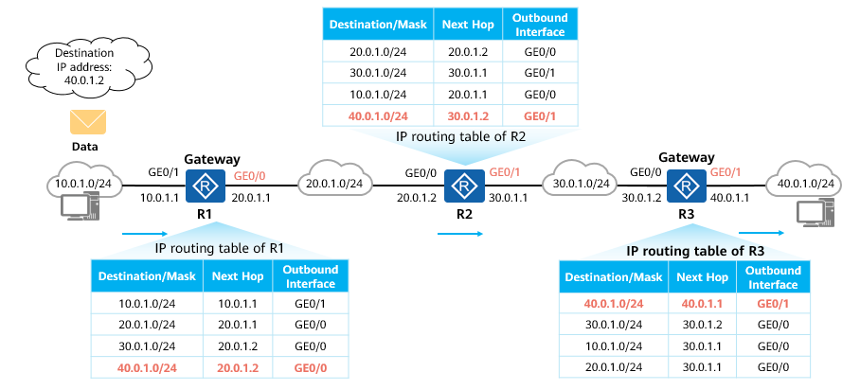

Route-based Forwarding Process

The IP packets from 10.0.1.0/24 need to reach 40.0.1.0/24. After receiving these packets, the gateway R1 searches its IP routing table for the next hop and outbound interface and forwards the packets to R2. After the packets reach R2, R2 forwards the packets to R3 by searching its IP routing table. Upon receipt of the packets, R3 searches its IP routing table, finding that the destination IP address of the packets belongs to the subnet where a local interface resides. Therefore, R3 directly forwards the packets to the destination subnet 40.0.1.0/24.

### Summary of the IP Routing Table

When a router obtains routes to the same destination subnet with the same mask from different routing protocols, the router prefers the route with the lowest preference value of these routing protocols. If these routes are learned from the same routing protocol, the router prefers the route with the lowest cost. In summary, only the optimal route is installed in the IP routing table.

When a router receives a packet, it searches its IP routing table for the outbound interface and next hop based on the destination IP address of the packet. If it finds a matching routing entry, it forwards the packet according to the outbound interface and next hop specified by this entry. Otherwise, it discards the packet.

Packets are forwarded hop by hop. Therefore, all the routers along the path from the source to the destination must have routes destined for the destination. Otherwise, packet loss occurs.

Data communication is bidirectional. Therefore, both forward and backward routes must be available.

## Static Routing

### Application Scenarios of Static Routes

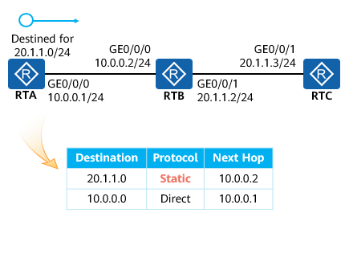

Static Routes

Static routes are manually configured by network administrators, have low system requirements, and apply to simple, stable, and small networks.

The disadvantage of static routes is that they cannot automatically adapt to network topology changes and so require manual intervention.

RTA needs to forward the packets with the destination address 20.1.1.0/24. However, the IP routing table of RTA has only one direct route, which does not match 20.1.1.0/24. In this case, a static route needs to be manually configured so that the packets sent from RTA to 20.1.1.0/24 can be forwarded to the next hop 10.0.0.2.

### Static Route Configuration

Specify a next-hop IP address for a static route.

[Huawei] **ip route-static** *ip-address* *{ mask | mask-length }* *nexthop-address*

Specify an outbound interface for a static route.

[Huawei] ***ip route-static ip-address { mask | mask-length } interface-type interface-number***

Specify both the outbound interface and next hop for a static route.

[Huawei] **ip route-static** *ip-address { mask | mask-length } interface-type interface-number [ nexthop-address ]*

* When creating a static route, you can specify both the outbound interface and next hop. Alternatively, you can specify either the outbound interface or next hop, depending on the interface type:
* For a point-to-point interface (such as a serial interface), you must specify the outbound interface.
* For a broadcast interface (for example, an Ethernet interface) or a virtual template (VT) interface, you must specify the next hop.

Configuration Example

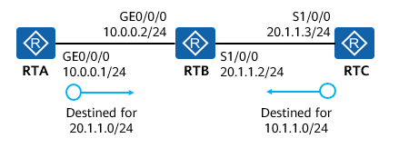

Configuration Example

Configure static routes on RTA and RTC for communication between 10.0.0.0/24 and 20.1.1.0/24.

Packets are forwarded hop by hop. Therefore, all the routers along the path from the source to the destination must have routes destined for the destination.

Data communication is bidirectional. Therefore, both forward and backward routes must be available.

Configure RTA.

[RTA] **ip route-static 20.1.1.0 255.255.255.0 10.0.0.2**

Configure RTC.

[RTC] **ip route-static 10.0.0.0 255.255.255.0 S1/0/0**

### Default Routes

Default routes are used only when packets to be forwarded do not match any routing entry in an IP routing table.

In an IP routing table, a default route is the route to network 0.0.0.0 (with the mask 0.0.0.0), namely, 0.0.0.0/0.

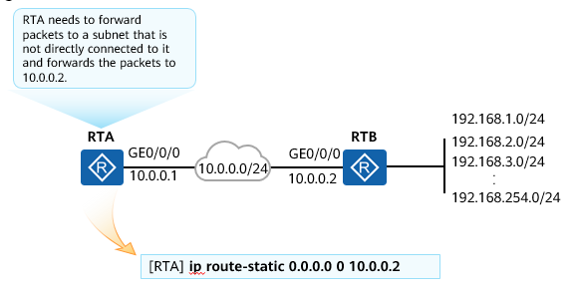

Default Routes

### Application Scenarios of Default Routes

Default routes are typically used at the egress of an enterprise network. For example, you can configure a default route on an egress device to enable the device to forward IP packets destined for any address on the Internet.

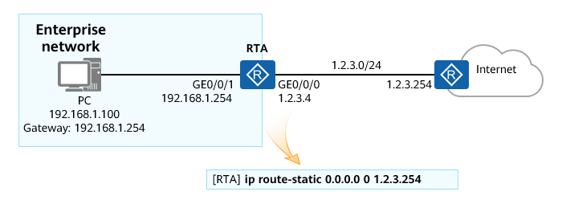

Application Scenarios of Default Routes

## Dynamic Routing

### Overview of Dynamic Routing

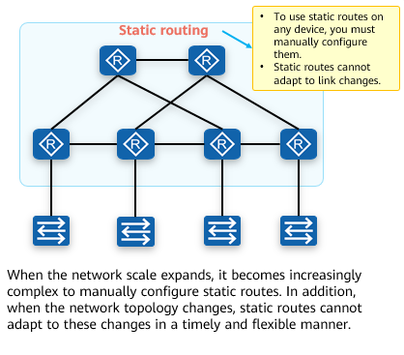

Static Routing

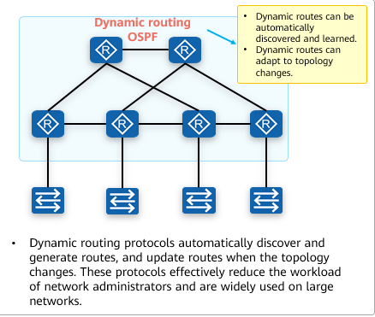

Dynamic Routing

The disadvantage of static routes is that they cannot automatically adapt to network topology changes and so require manual intervention.

Dynamic routing protocols provide different routing algorithms to adapt to network topology changes. Therefore, they are applicable to networks on which many Layer 3 devices are deployed.

### Classification of Dynamic Routing Protocols

Dynamic routing protocols are classified into two types based on the routing algorithm:

* Distance-vector routing protocol
  + RIP
* Link-state routing protocol
  + OSPF
  + IS-IS
* BGP uses a path vector algorithm, which is modified based on the distance-vector algorithm. Therefore, BGP is also called a path-vector routing protocol in some scenarios.

Dynamic routing protocols are classified into the following types by their application scope:

* IGPs run within an autonomous system (AS), including RIP, OSPF, and IS-IS.
* EGP runs between different ASs, among which BGP is the most frequently used.

## Advanced Routing Features

### Route Recursion

Route recursion is a recursive search process of the IP routing table where the next-hop IP address is wanted to route packets towards its destination but when found it is not part of any directly connected network.

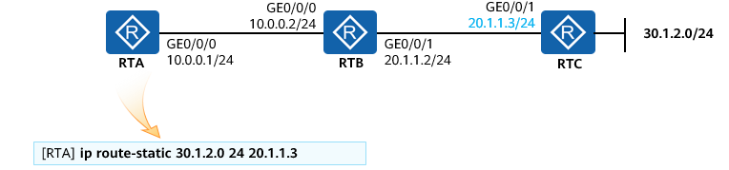

Route Recursion (1)

* The next hop of the route to 30.1.2.0/24 is 20.1.1.3, which is not on a directly connected network of RTA. If the IP routing table does not have a route to 20.1.1.3, this static route does not take effect and cannot be installed in the IP routing table.

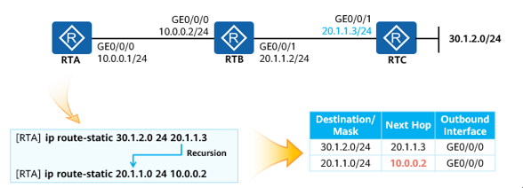

Route Recursion (2)

* Configure a route to 20.1.1.3, with the next hop pointing to 10.0.0.2 on the directly connected network.
* In this way, RTA can recurse the route with the destination 30.1.2.0/24 to the route with the destination 10.0.0.2.

### Equal-Cost Route

When there are equal-cost routes in the IP routing table, a router forwards IP packets to be sent to the destination subnet through all valid outbound interfaces and next hops in the equal-cost routes, achieving load balancing.

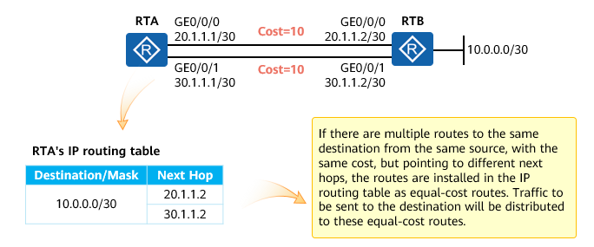

Equal-Cost Route

### Floating Route

Basic Concepts

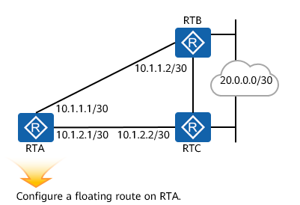

[RTA] **ip route-static 20.0.0.0 30 10.1.1.2**

[RTA] **ip route-static 20.0.0.0 30 10.1.2.2 preference 70**

Floating Route

* Different preferences can be manually configured for static routes. Therefore, you can configure two static routes with the same destination address/mask but different preferences and next hops to implement backup of forwarding paths.
* A backup route is known as a floating route, which is used only when the primary route is unavailable. That is, a floating route is installed in the IP routing table only when the next hop of the primary route is unreachable.

Example

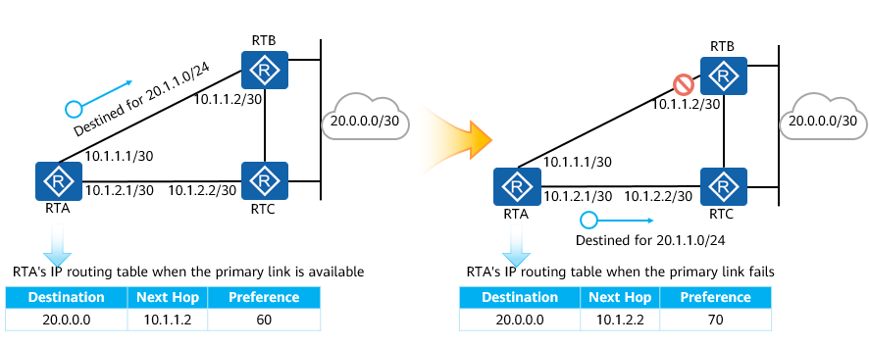

Floating Route Switching

* When the link between RTA and RTB is normal, the two routes to 20.0.0.0/30 are both valid. In this case, RTA compares the preferences of the two routes, which are 60 and 70 respectively. Therefore, the route with the preference value 60 is installed in the IP routing table, and RTA forwards traffic to the next hop 10.1.1.2.
* If the link between RTA and RTB is faulty, the next hop 10.1.1.2 is unreachable, which causes the corresponding route invalid. In this case, the backup route to 20.0.0.0/30 is installed in the IP routing table. RTA forwards traffic destined for 20.0.0.1 to the next hop 10.1.2.2.

### CIDR

Classless Inter-Domain Routing (CIDR) uses IP addresses and masks to identify networks and subnets. CIDR replaces the previous addressing architecture of classful network design (such as classes A, B, and C addresses).

CIDR is based on variable length subnet mask (VLSM). CIDR uses prefixes of any lengths to divide the address space with continuous IP addresses. Multiple address segments with continuous prefixes can be summarized into a network, effectively reducing the number of routing entries.

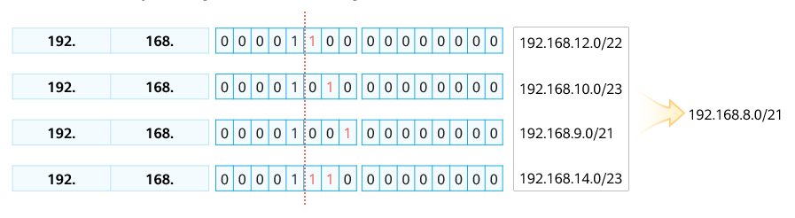

CIDR

### Background of Route Summarization

Subnet division and VLSM resolve the problem of address space waste, but also bring a new challenge: increasing routing entries in the IP routing table.

Route summarization can minimize routing entries.

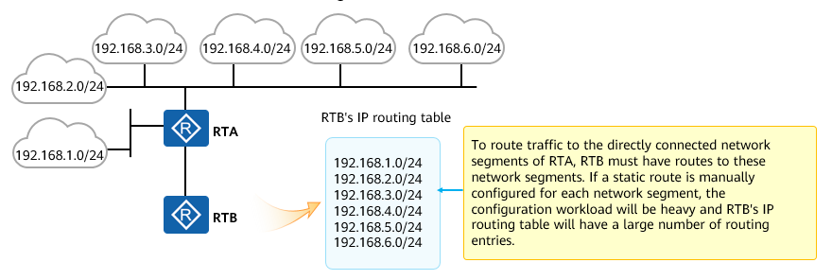

Background of Route Summarization

On a large-scale network, routers or other routing-capable devices need to maintain a large number of routing entries, which will consume a large amount of device resources. In addition, the IP routing table size is increasing, resulting in a low efficiency of routing entry lookup. Therefore, we need to minimize the size of IP routing tables on routers while ensuring IP reachability between the routers and different network segments. If a network has scientific IP addressing and proper planning, we can achieve this goal by using different methods. A common and effective method is route summarization, which is also known as route aggregation.

### Overview of Route Summarization

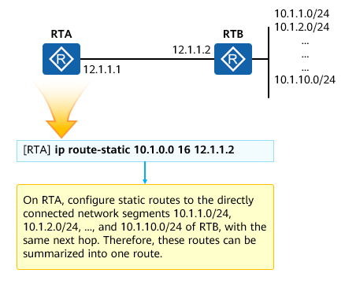

Overview of Route Summarization

Route summarization is an approach of summarizing routes with the same prefix into one summary route to minimize the IP routing table size and improve device resource usage.

Route summarization uses CIDR to summarize network segments with the same prefix into a single one.

The routes before being summarized are known as specific routes, and the routes created after summarization are known as summarized routes or summary routes.

To enable RTA to reach remote network segments, we need to configure a specific route to each network segment. In this example, the routes to 10.1.1.0/24, 10.1.2.0/24, and 10.1.3.0/24 have the same next hop, that is, 12.1.1.2. Therefore, we can summarize these routes into a single one.

This effectively reduces the size of RTA's IP routing table.

### Summarization and Calculation

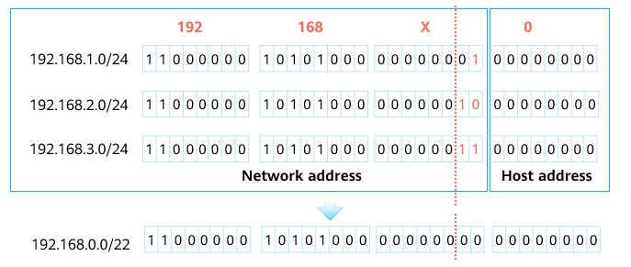

Summarization and Calculation

To summarize routes to multiple continuous network segments into one summary route that just includes these network segments, ensure that the mask length of the summary route is as long as possible.

The key to achieve this is to convert the destination addresses of specific routes into binary numbers and then find out the identical bits in these binary numbers.

### Problems Caused by Route Summarization

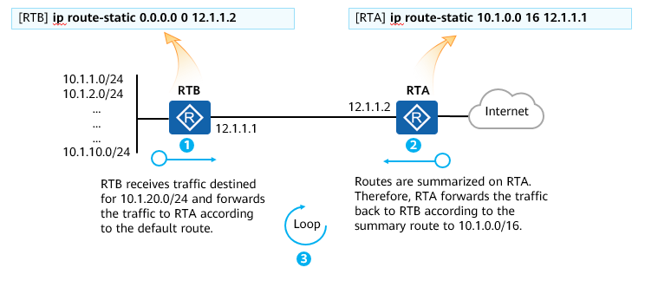

Routing Loop

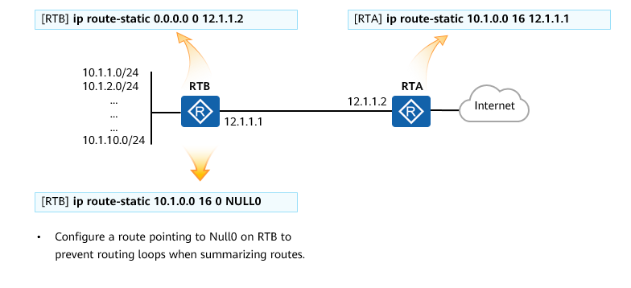

Solution for Preventing Routing Loops

In most cases, both static and dynamic routes need to be associated with an outbound interface. This interface is the egress through which the device is connected to a destination network. The outbound interface in a route can be a physical interface such as a 100M or GE interface, or a logical interface such as a VLANIF or tunnel interface. There is a special interface, that is, Null interface. It has only one interface number, that is, 0. Null0 is a logical interface and is always up. When Null0 is used as the outbound interface in a route, data packets matching this route are discarded, like being dumped into a black-hole. Therefore, such a route is called a black-hole route.

### Accurate Route Summarization

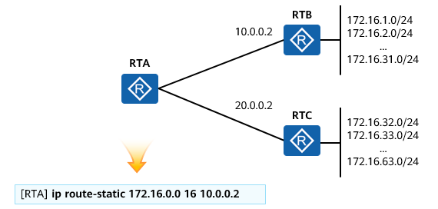

Accurate Route Summarization (1)

* To simplify the configuration, an administrator may configure a static summary route on RTA to allow RTA to reach network segments 172.16.1.0/24 to 172.16.31.0/24 of RTB. However, this summary route also includes the network segments of RTC. As a result, RTA forwards the traffic destined for network segments of RTC to RTB, causing data packet loss. This problem is caused by inaccurate route summarization. To resolve this problem, the summary route must be as accurate as possible; that is, it just covers all specific routes that are to be summarized, with no extra route included.

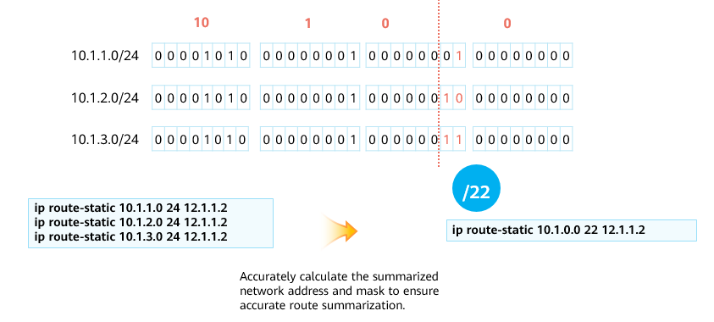

Accurate Route Summarization (2)

## Quiz

1. (Single) Which of the following information is not included in the routing table? ( )
2. Source address
3. Destination address
4. Outbound interface
5. Next hop
6. (Single) If a device discovers the route to 10.0.0.0/30 using both the dynamic routing protocol OSPF and static routing protocol, which of the following situations occurs? ( )
7. Add the routes discovered by OSPF to the routing table.
8. Add the routes discovered by static routes to the routing table.
9. Add the two types of discovered routes to the routing table.
10. Neither of them is added to the routing table.
11. (Multiple)When a router receives a packet with the destination address 10.1.1.1, which of the following entries can match the destination address? ( )
12. 0.0.0.0/0
13. 10.1.1.0/24
14. 10.1.1.0/30
15. 10.1.1.4/30
16. (True or False)If a device learns the route with the mask of 10.1.1.0/24 through OSPF and the route with the mask of 10.1.1.0/30 through a static route, the router adds the two routes to the routing table.（ ）
17. True
18. False
19. (True or False)OSPF and IS-IS are both internal gateway protocols and link-state protocols.（ ）
20. True
21. False
22. How does a router select the optimal route?
23. How do I configure a floating route?
24. What is the summary route for routes to 10.1.1.0/24, 10.1.3.0/24, and 10.1.9.0/24?

## Summary

This section presents the basic concepts of routes, how routes instruct routers to forward IP packets, common route attributes, and default routes (special static routes).

In addition, this section describes advanced routing features including route recursion, floating routes, and equal-cost routes, which are widely used on live networks.